**Exercise 3: Code Refactoring & Analysis**

### **Objective:** Refactor your existing Python code (e.g., in main.py) to improve clarity and efficiency.

## **Step-by-Step Instructions:**

### **Review Your Code**

* 1. Open main.py in VS Code.
  2. Read through the code and identify a function or block that looks “messy” or could be optimized.
  3. Add a comment above the code, for example:

| # TODO: Refactor this function for clarity and performance |
| --- |

### **Ask GitHub Copilot for Suggestions**

* 1. Place your cursor where you want improvements.
  2. GitHub Copilot may display a suggestion—review it carefully.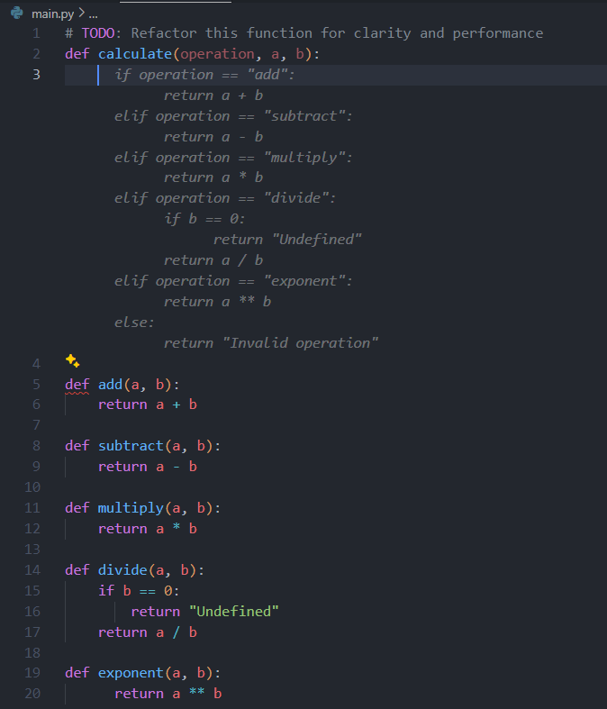
  3. Press Tab to accept a suggestion, or modify it to suit your needs.
  4. Make additional comments if necessary (e.g., # Improve error handling).

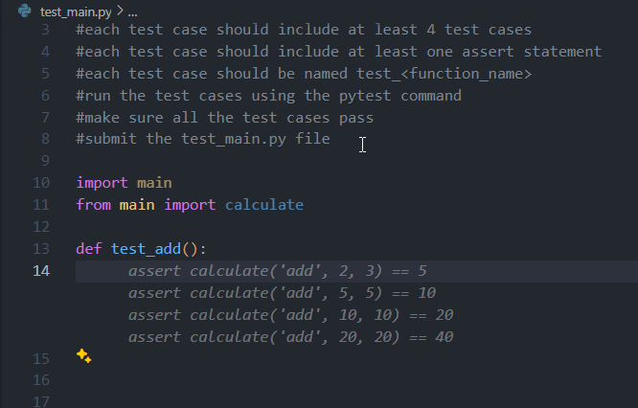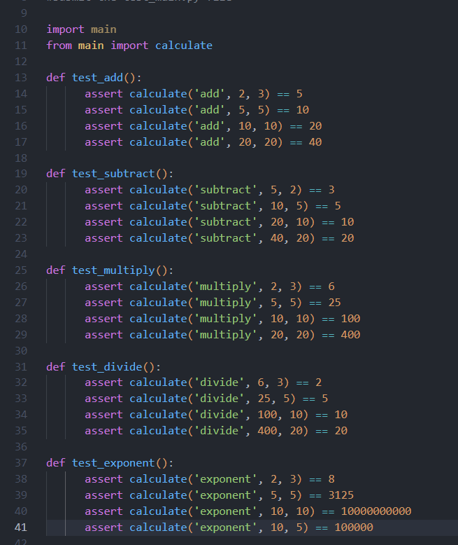

### **Save and Test**

* 1. Save your changes.
  2. Run your test suite (e.g., using pytest) to ensure nothing is broken.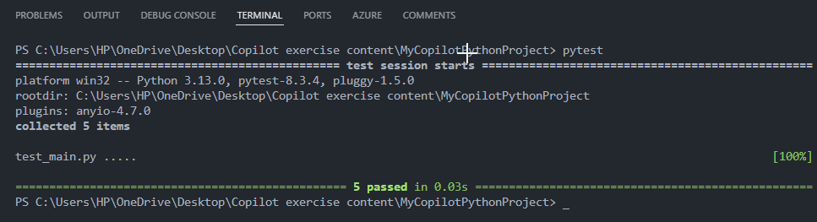
  3. If tests fail, iterate with further suggestions from Copilot.

### **(Optional) Commit Your Changes**

* 1. Open the terminal and run:

| git add . git commit -m "Refactored code in main.py with Copilot suggestions" |
| --- |

Voila!! We have successfully completed this exercise.